AYN RAND ARCHIVES GALLERY

Front Exterior

(Featuring Garden and Moat with Pedestrian Bridge)

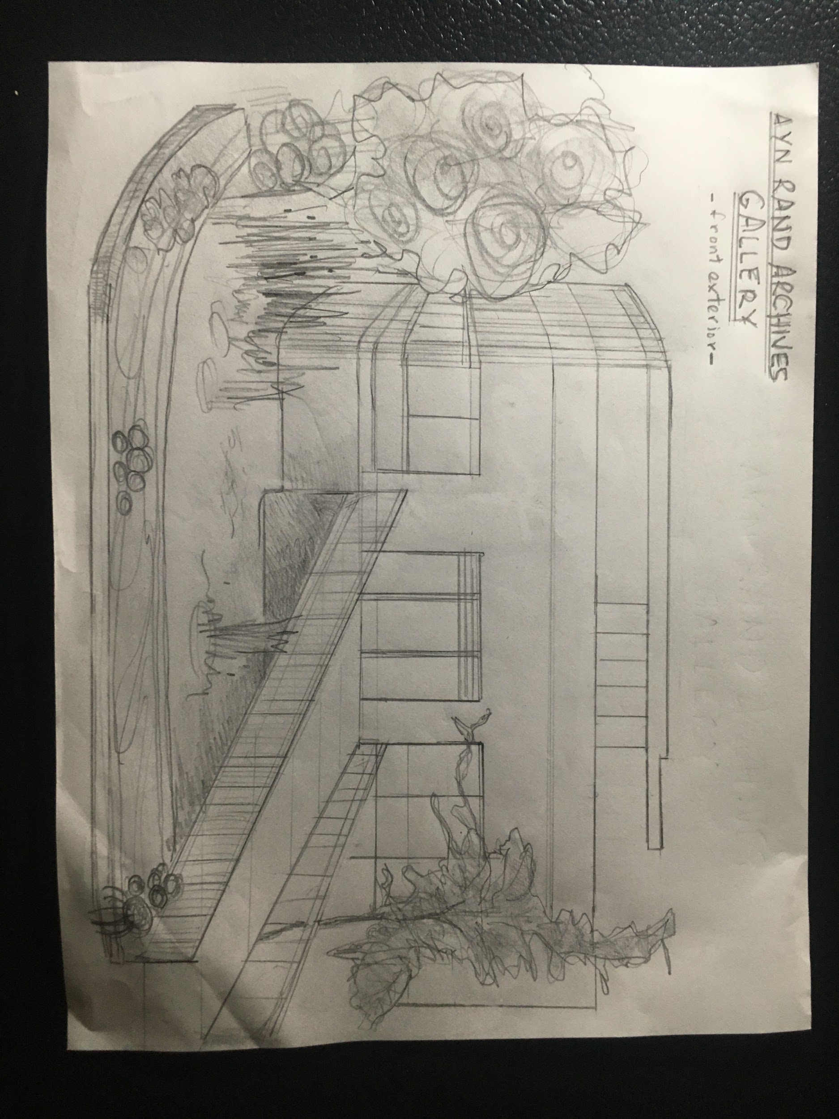

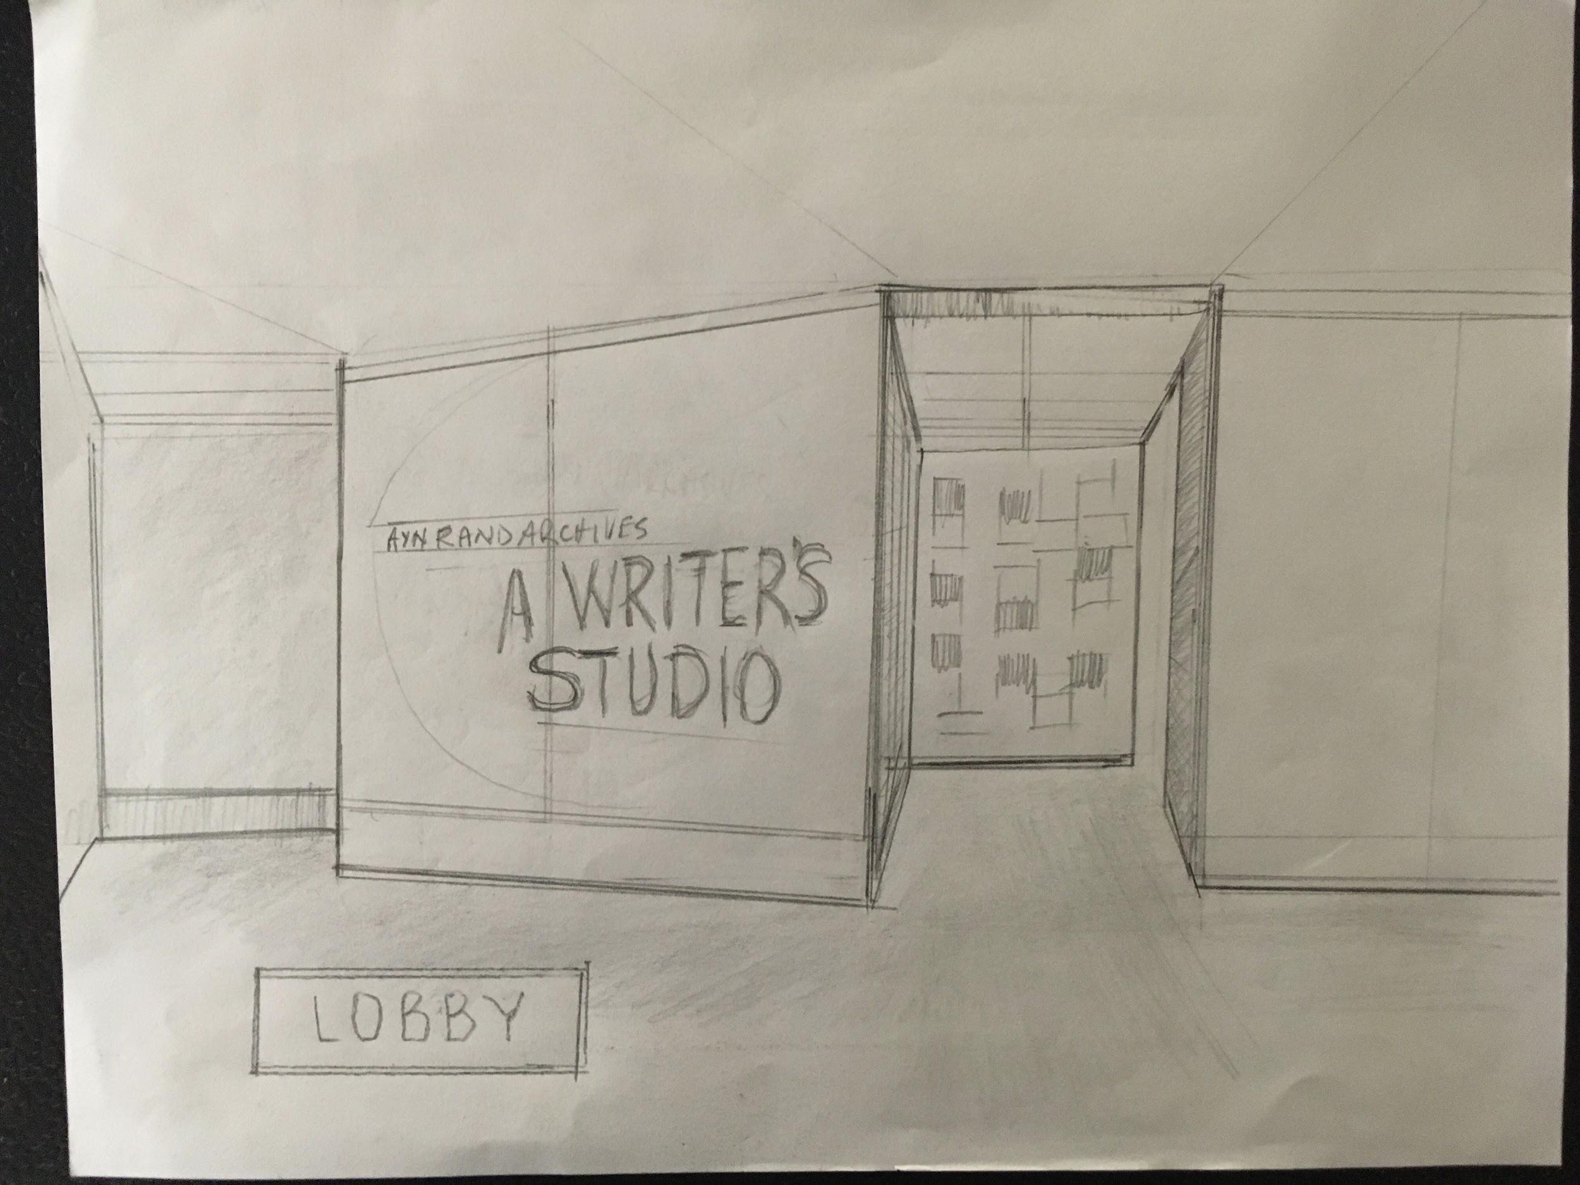

ARCHIVES BUILDING LOBBY

Exhibit Entrance

(Exhibition Signage)

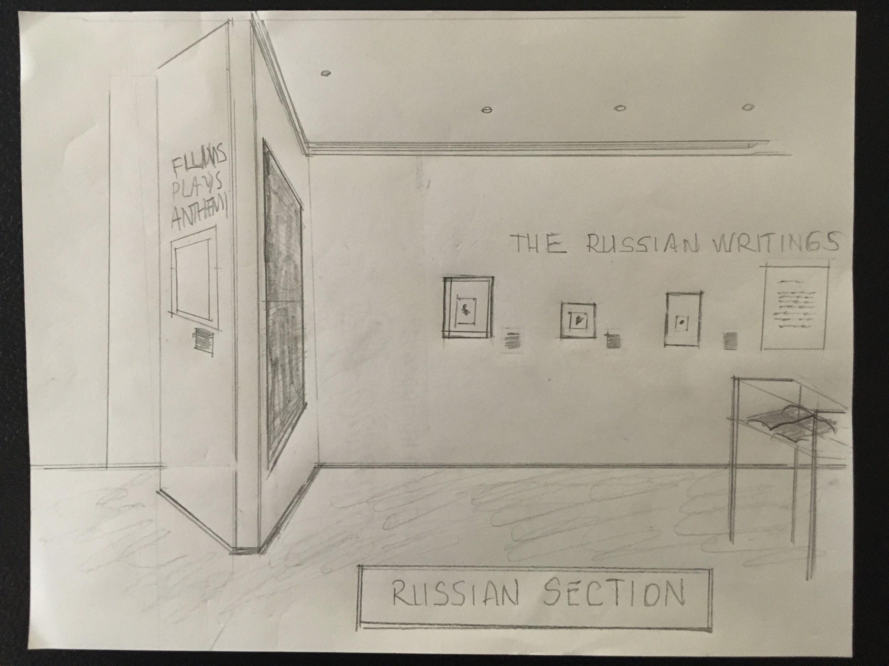

EXHIBIT INTERIOR - RUSSIAN SECTION

Side View

(New Section Entrance at Left)

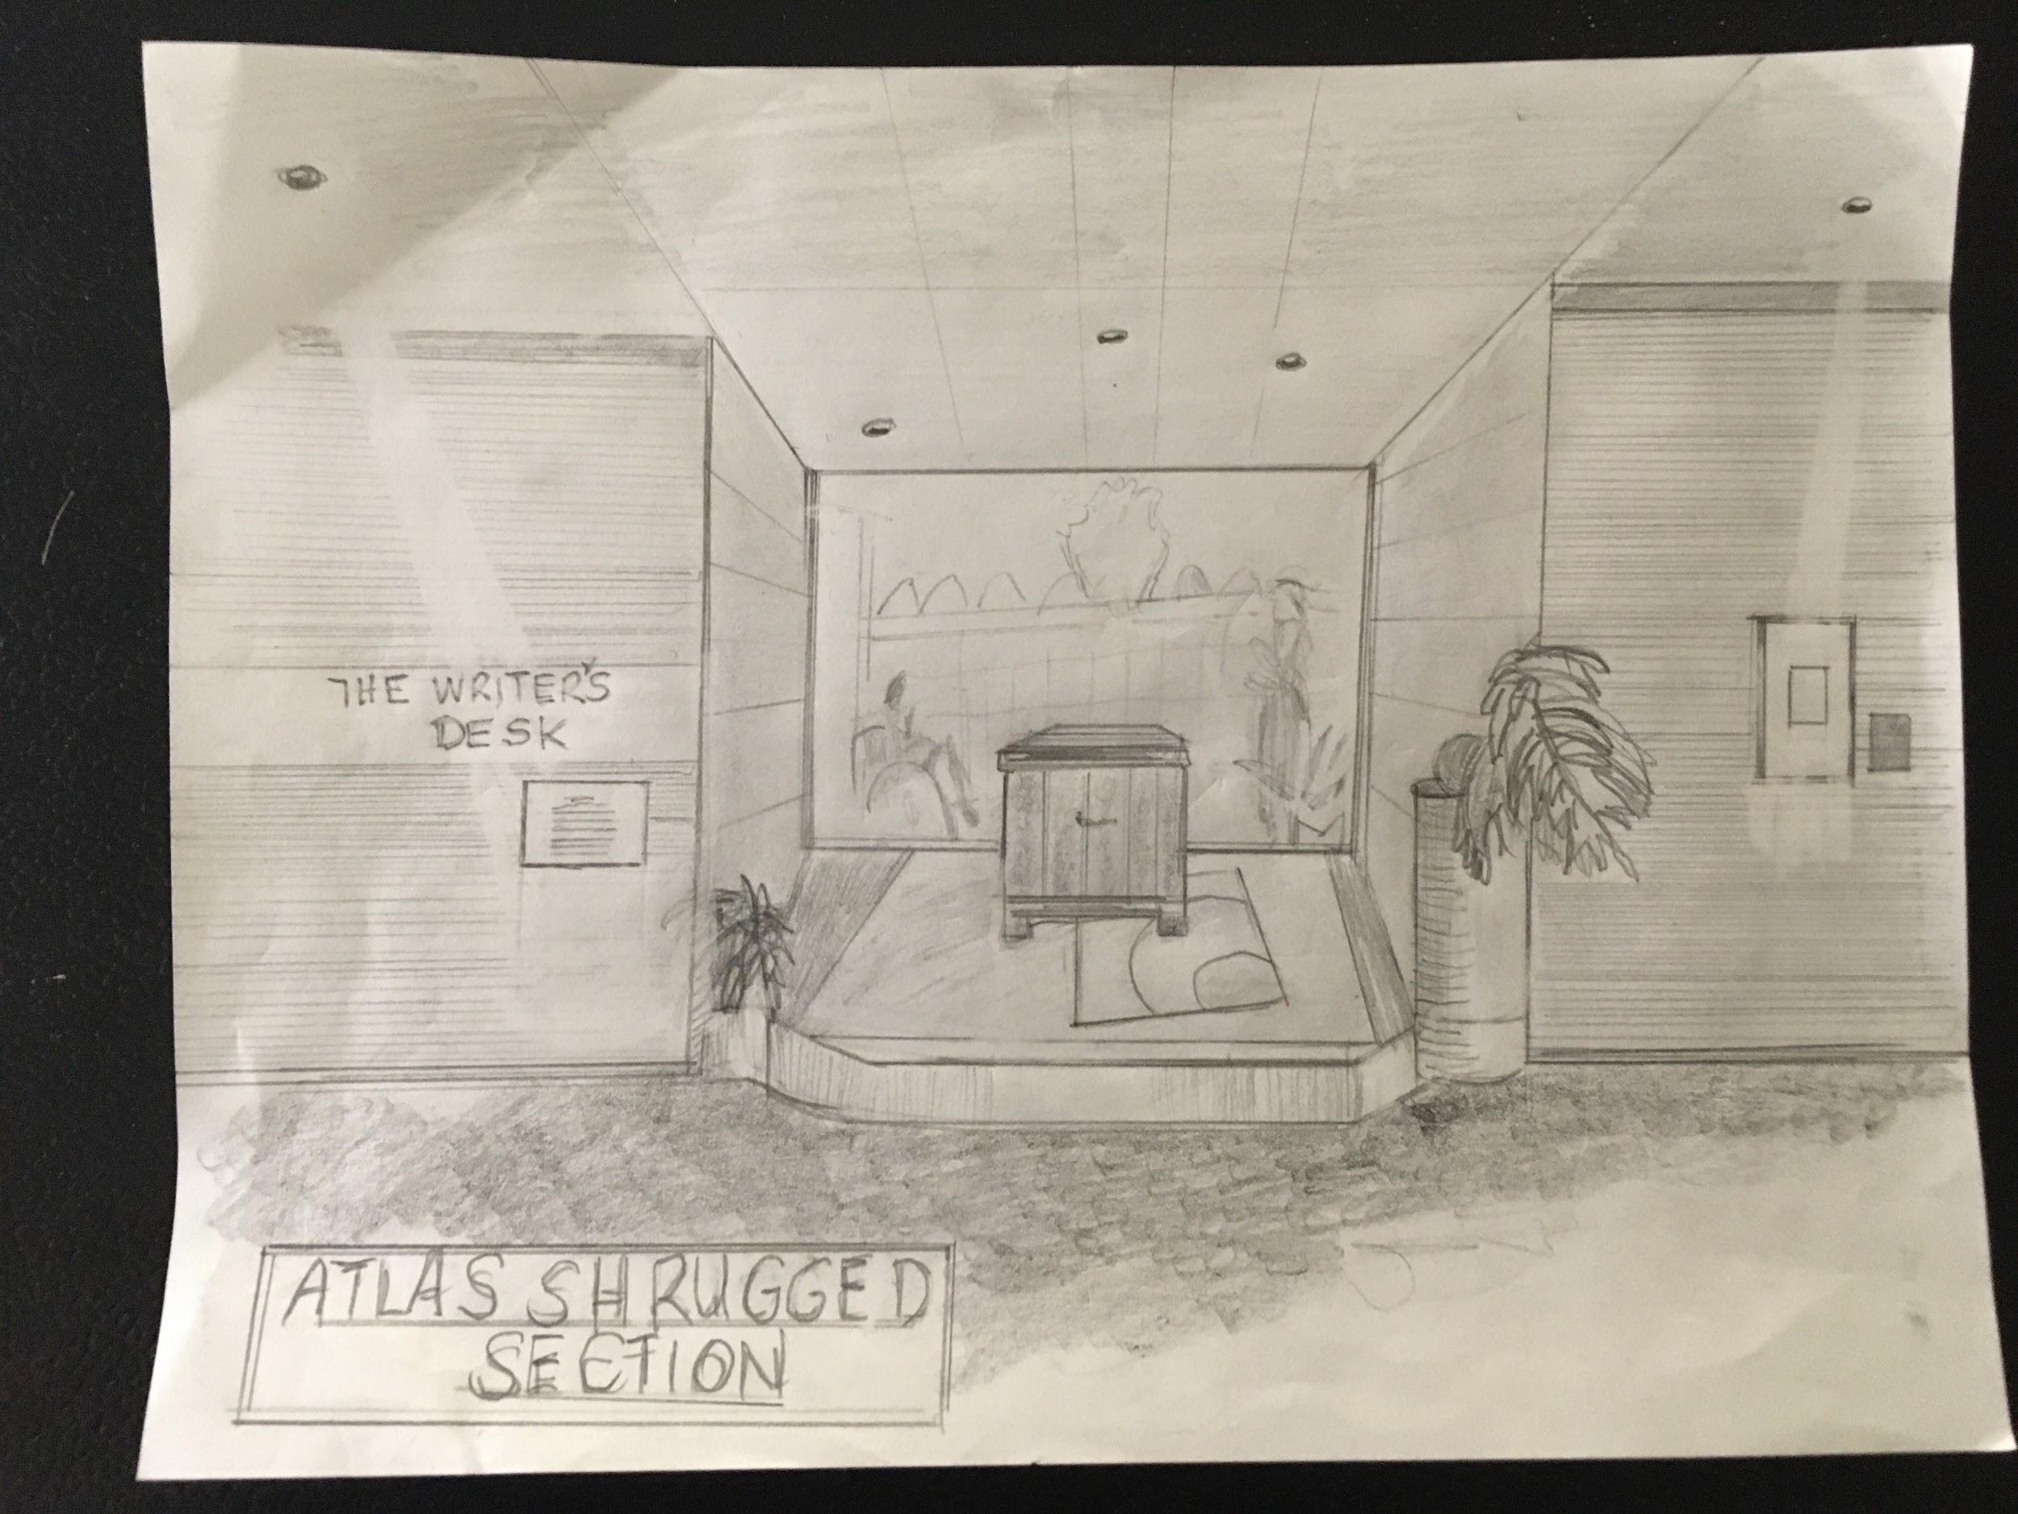

ATLAS SHRUGGED SECTION

Desk Diorama

(Featuring a Julius Shulman portrait of The O’Connors on Lightbox)